

LABORATORY PROJECT REPORT
BLUETOOTH DATA INTERFACING

EXPERIMENT 9
Section 1
Group 7
Semester 2 2025/2026

1. | MUHAMMAD FARISH BIN AB LATIF | 2329227
2. | MUHAMMAD FARQI SARHIDI BIN ABDUL HAFAZ | 2316461
3. | MUHAMMAD DANISH BIN MOHD HANIFAH | 2311377

DATE OF SUBMISSION: 13 MAY 2026

Abstract

This experiment aims to create a wireless monitoring and control system by utilizing Bluetooth communication between an ESP32 or an Arduino paired with an HC-05 module and an external device such as a smartphone or computer. Rather than using a temperature sensor, a potentiometer is applied to produce adjustable analog input values, which are transmitted via Bluetooth for real-time observation. Furthermore, basic control commands like “FAN ON” and “FAN OFF” are implemented to illustrate remote control capability. In general, the experiment shows how Bluetooth Serial communication can enable two-way interaction between a microcontroller and a connected device for IoT-based monitoring and control systems.

Table of Contents
1.0 Introduction
2.0 Materials and Equipment
2.1 Electronic Components
2.2 Equipment and Tools
3.0 Experimental Setup
4.0 Methodology
5.0 Data Collection
6.0 Data Analysis
7.0 Results
8.0 Discussion
9.0 Conclusion
10.0 Recommendations
11.0 References

1.0 Introduction
Wireless communication plays a significant role in modern embedded systems, particularly in IoT (Internet of Things) and remote monitoring technologies. Among the various wireless methods available, Bluetooth is commonly utilized due to its simple implementation, low power consumption, and compatibility with smartphones and computers.
This project designs a Bluetooth-based monitoring and control system using an ESP32 or Arduino integrated with an HC-05 Bluetooth module. Instead of a temperature sensor, a potentiometer serves as the input component to generate adjustable analog readings for the microcontroller. These potentiometer readings are then sent wirelessly through Bluetooth to a connected smartphone or computer for real-time observation. At the same time, the system is capable of receiving user commands to operate external devices such as a fan or LED indicator, demonstrating basic remote-control features.
The primary aim of this project is to gain an understanding of analog data acquisition, Bluetooth serial communication, and bidirectional communication between a microcontroller and an external device. In addition, this project introduces concepts that are widely used in IoT systems, wireless monitoring, smart home automation, and remote-control applications.

2.0 Materials and Equipment

2.1 Electronic Components
- ESP32 dev board
- Potentiometer
- Smartphone or computer with Bluetooth support
2.2 Equipment and Tools
- Power supply for the ESP32
- Breadboard

● Jumper wires 3.0

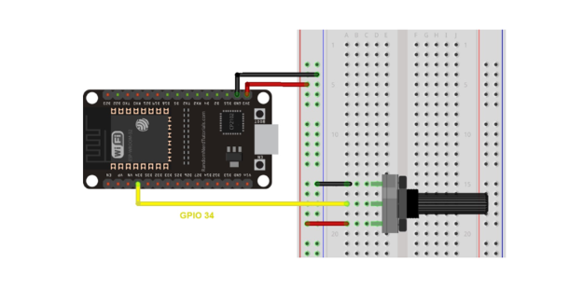
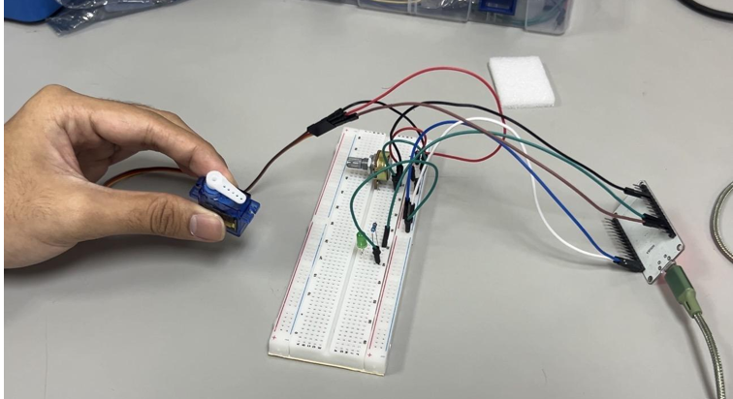

Experimental Setup
- Hardware Setup:
  - Connect the potetntiometer sensor to the ESP32. - Power up the system.
- Arduino Programming:
Write an Arduino sketch to:
  - Read temperature data from the potetntiometer sensor.
  - Transmit the data over Bluetooth serial connection.
  - Receive simple commands (e.g., ” ON”, “ OFF”) via Bluetooth.
- Bluetooth Programming:
  - Pair the ESP32 Bluetooth with the smartphone.
  - Use a serial terminal app to view data and send commands.
- Remote Monitoring:
  - Observe real-time temperature readings on paired device. - Send control commands to toggle the LED.

4.0 Methodology
Hardware Setup
- ESP32 development board or Arduino Uno with HC-05 Bluetooth module
- DHT22 temperature and humidity sensor connected to the microcontroller
- Jumper wires and breadboard
- Power supply via USB
- Smartphone/PC with Bluetooth terminal app

Steps:
- Connect the potentiometer terminals properly: one side terminal to 3.3V/5V, the other side terminal to GND, and the middle pin (wiper) to an analog input pin (e.g., A0 for Arduino or VP/GPIO36 for ESP32).
- For Arduino: Connect HC-05 TX → Arduino RX and HC-05 RX → Arduino TX using SoftwareSerial pins 2 and 3.
- Power up the microcontroller using a USB connection.
- Ensure all ground (GND) connections are shared between the microcontroller, HC-05 module, and potentiometer.

Programming codes
#include "BluetoothSerial.h"
#include <ESP32Servo.h>
BluetoothSerial SerialBT;
Servo myServo;
// Pin Definitions
const int potpin = 34; // Potentiometer input const int servoPin = 13; // Signal pin for the Servo const int LED = 14; // Built-in LED for feedback char command; int potValue = 0; void setup() {
Serial.begin(9600);
// Start Bluetooth with your preferred display name
SerialBT.begin("Group 2"); // Setup hardware myServo.attach(servoPin); pinMode(LED, OUTPUT);
Serial.println("System Initialized. Connect your smartphone via Bluetooth.");
} void loop() {
// 1. Read Potentiometer (Sensor) data potValue = analogRead(potpin);
// 2. Transmit the value to the smartphone terminal
SerialBT.print("Sensor (Pot) Value: ");
SerialBT.println(potValue);
// 3. Check for incoming Bluetooth commands if (SerialBT.available()) { command = SerialBT.read(); // Process commands to move the Servo switch (command) {
case '1': // Move to start position myServo.write(0); digitalWrite(LED, HIGH); SerialBT.println("Action: Servo set to 0°"); break; case '2': // Move to middle position myServo.write(90);
SerialBT.println("Action: Servo set to 90°"); break; case '3': // Move to end position myServo.write(180); digitalWrite(LED, LOW);
SerialBT.println("Action: Servo set to 180°"); break;
}
}
// Delay to prevent flooding the Bluetooth terminal delay(1000);
}

5.0 Data Collection

The data collection procedure was conducted using an ESP32 microcontroller connected to a potentiometer as the analog input component. The potentiometer was attached to an analog input pin (for example, GPIO 34), where it generated varying voltage readings depending on the rotation of the knob. Bluetooth communication was enabled through the ESP32’s integrated Bluetooth module. The system was powered using a USB connection, while the Bluetooth pairing was established with a smartphone through a serial Bluetooth terminal application.

The potentiometer’s analog readings were transmitted wirelessly from the ESP32 to the connected device at intervals of about 2 seconds. The transmitted data were displayed instantly on the Bluetooth terminal application in real time. Throughout the experiment, the readings were continuously monitored and manually noted over several minutes to observe variations in the analog input values.

Besides data transmission, remote control functions were also evaluated by sending simple text commands such as “ON” and “OFF” through the Bluetooth terminal. These commands were utilized to switch the onboard LED of the ESP32 on and off, serving as a simulated output indicator or control device. The corresponding system responses were monitored to verify successful two-way Bluetooth communication. All potentiometer values and system reactions were recorded for additional analysis.

6.0 Data Analysis
The collected data from the potentiometer were analyzed according to the variations in its analog output detected by the ESP32 microcontroller. As the potentiometer knob was rotated, different voltage levels were generated and converted into digital readings through the microcontroller’s ADC. These readings were then sent to a smartphone via Bluetooth at intervals of around 2 seconds for real-time observation.
The findings indicated that the potentiometer readings varied smoothly and proportionally with the movement of the knob. Rotating the knob toward one side caused the readings to decrease toward the lower ADC range, whereas turning it in the opposite direction increased the readings toward the maximum range. Minor fluctuations were detected during the data collection process, possibly caused by electrical noise or slight instability in the analog signal. Nevertheless, these small variations did not greatly impact the overall accuracy of the measurements.
Furthermore, the Bluetooth connection remained stable during the entire experiment, providing continuous data transmission without noticeable delays. The system also reacted properly to control instructions such as “ON” and “OFF,” verifying successful two-way communication between the microcontroller and the external device. Overall, the project successfully demonstrated dependable real-time analog data monitoring using a potentiometer within an IoT-based system.

7.0 Results
The ESP32 and the connected device were able to communicate successfully via Bluetooth throughout the experiment. Instead of using a temperature sensor, a potentiometer served as the input device, producing variable analog values based on the rotation of its knob. These readings were transmitted at 2-second intervals and were consistently displayed on the Bluetooth terminal application. The recorded data showed smooth and steady variations in value corresponding to adjustments of the potentiometer, indicating that both the input component and communication system were operating correctly. The transmission remained stable during the entire experiment with no significant delays, aside from occasional minor fluctuations likely caused by ADC noise.
In addition to data transfer, the system also demonstrated remote control capability. Commands such as “ON” and “OFF” were sent through the Bluetooth terminal and were promptly received by the microcontroller. The ESP32 responded by successfully toggling the simulated output, showing that the control instructions were executed correctly and without delay. Overall, the results verified that the Bluetooth connection effectively supported both real-time monitoring of potentiometer data and reliable two-way communication for remote control functions.

8.0 Discussion
The demonstration successfully showed how Bluetooth technology can be applied for wireless communication in embedded systems. In this setup, a potentiometer replaced a temperature and humidity sensor, providing adjustable analog input values. These values were continuously transmitted to a connected device using the HC-05/ESP32 Bluetooth serial module. The stable Bluetooth connection observed during the monitoring process emphasized its suitability for low-power IoT applications.
When control commands were issued from a smartphone or computer, the microcontroller responded correctly, demonstrating proper processing of serial input. This function simulates basic remote operation of external devices such as lights, fans, or other actuators. The quick response time also indicated that Bluetooth communication offers low latency for simple control tasks.
Although the 2-second sampling interval introduced slight delays between updates, it was still suitable for observing gradual changes in potentiometer readings. Unlike environmental sensors, the potentiometer provides immediate and continuous variation, making it ideal for real-time input demonstrations. Overall, the system effectively demonstrated wireless data transmission, microcontroller programming, and basic IoT-based remote control using simple serial communication.

9.0 Conclusion
The objective of this experiment, which was to design a Bluetooth-based monitoring and control system, was successfully accomplished. Instead of using a temperature sensor, a potentiometer was implemented to generate variable analog input values, which were accurately read by the ESP32/Arduino and transmitted to a PC or smartphone. The system consistently displayed these potentiometer readings in real time, indicating stable and reliable data communication.
In addition to monitoring functions, the Bluetooth connection also enabled user-defined commands to control external outputs. The microcontroller responded appropriately to instructions sent from the connected device, demonstrating correct execution of serial communication for basic control operations. This confirmed that the system was capable of handling both data transmission and command reception without significant delay.
Overall, the experiment effectively demonstrated the fundamental principles of IoT connectivity, including wireless data transfer, real-time monitoring, and remote control using Bluetooth communication. It also serves as a solid foundation for the development of more advanced embedded systems and smart device applications in the future.

10.0 Recommendations
Several improvements could be introduced in the future to enhance the system’s functionality, accuracy, and efficiency. First, replacing the current sensor setup with a more advanced sensor such as the BME280 or DS18B20 would improve measurement accuracy and provide more stable readings. Implementing a data logging feature, either through an SD card module or cloud-based storage, would allow long-term monitoring and enable trend analysis over time.
Additionally, the basic Bluetooth terminal could be upgraded to a dedicated mobile or desktop application that offers better visualization, including graphs and real-time dashboards. Expanding the system with additional control features would also allow multiple actuators to be managed, improving its flexibility for automation and smart home applications. Finally, improving communication security by using encrypted Bluetooth protocols or password authentication would make the system more suitable for real-world IoT applications where data protection and integrity are essential.

11.0 References
- Arduino Bluetooth Basic Tutorial
- Arduino and HC-05 Bluetooth Module Complete Tutorial
- Basic Bluetooth communication with Arduino & HC-05

Acknowledgements
Special thanks to Dr. ZULKIFLI BIN ZAINAL ABIDIN and Dr. WAHJU SEDIONO for their guidance and support during this experiment.

Student’s Declaration

Certificate of Originality and Authenticity
We hereby certify that we are collectively responsible for the work presented in this report. The content reflects our original work, except where specific references or acknowledgements have been made. No part of this report has been completed or submitted by individuals or sources not identified within.
Furthermore, we confirm that this report is the result of a collaborative effort, with contributions made by all group members. The extent of each individual’s contribution is documented within this certificate.
We also hereby certify that we have read and understand the content of the total report and no further improvement on the reports is needed from any of the individual’s contributors to the report.
We therefore, agreed unanimously that this report shall be submitted for marking and this final printed report has been verified by us.
Signature: FARISH Read [ / ]
Name: MUHAMMAD FARISH BIN AB LATIF Understand [ / ]
Matric Number: 2329227 Agree [ / ]

Signature: FARQI Read [ / ]
Name: MUHAMMAD FARQI SARHIDI BIN ABDUL HAFAZ Understand [ / ]
Matric Number: 2316461 Agree [ / ]

Signature: DANISH Read [ / ]
Name: MUHAMMAD DANISH BIN MOHD HANIFAH
Understand [ / ]
Matric Number: 2311377 Agree [ / ]

